INDIAN INSTITUTE OF INFORMATION TECHNOLOGY DESIGN AND MANUFACTURING JABALPUR



Design and Fabrication project

DS3001

DESIGN AND ANALYSIS OF FOREST MAP USING 3D DESIGN SOFTWARE

Faculty Incharge: Dr. Tripti Singh

Group Members:

1. Mallavarapu Abhishikth (20BCS124)
2. Meravath Pavan Kumar (20BCS130)
3. Ramireddy KalyanKumarreddy (20BCS179)
4. Sompalle Chandra Sekhar Reddy (20BCS218)
5. VVSD Charan (20BCS244)
6. Banoth Ram Naik (20BME017)
7. Janni Umesh Kumar (20BME024)

**Field Study** :

* One of the major issues faced by tribal people is losing their cattle because of wild animal attacks. Tribal people are mainly dependent on their cattle for their living.
* Our main aim of doing this project is to create such map which helps people to know information regarding areas of wild animal mobility.
* The map we have created will help people identify safe zones for cattle to live and graze as well as danger zones with high mobility of wild animals.
* The map we will create will also help tourists to know about restricted regions and safe regions in the forest.

**Technologies Used :**

* Blender software to create a 3-D model of the forest.
* Google Earth as a reference for models and boundaries.
* ArcGIS for creating a 2-D outline with coordinates.

**Work accomplished :**

* To gather information about the forest like boundaries, core areas, roads, water bodies. firstly, we have contacted the Bhuvan and Forest department of Madhya Pradesh but unfortunately they denied our request because the information about the forest is confidential So, we searched in the online and got some date from various public resourses.
* 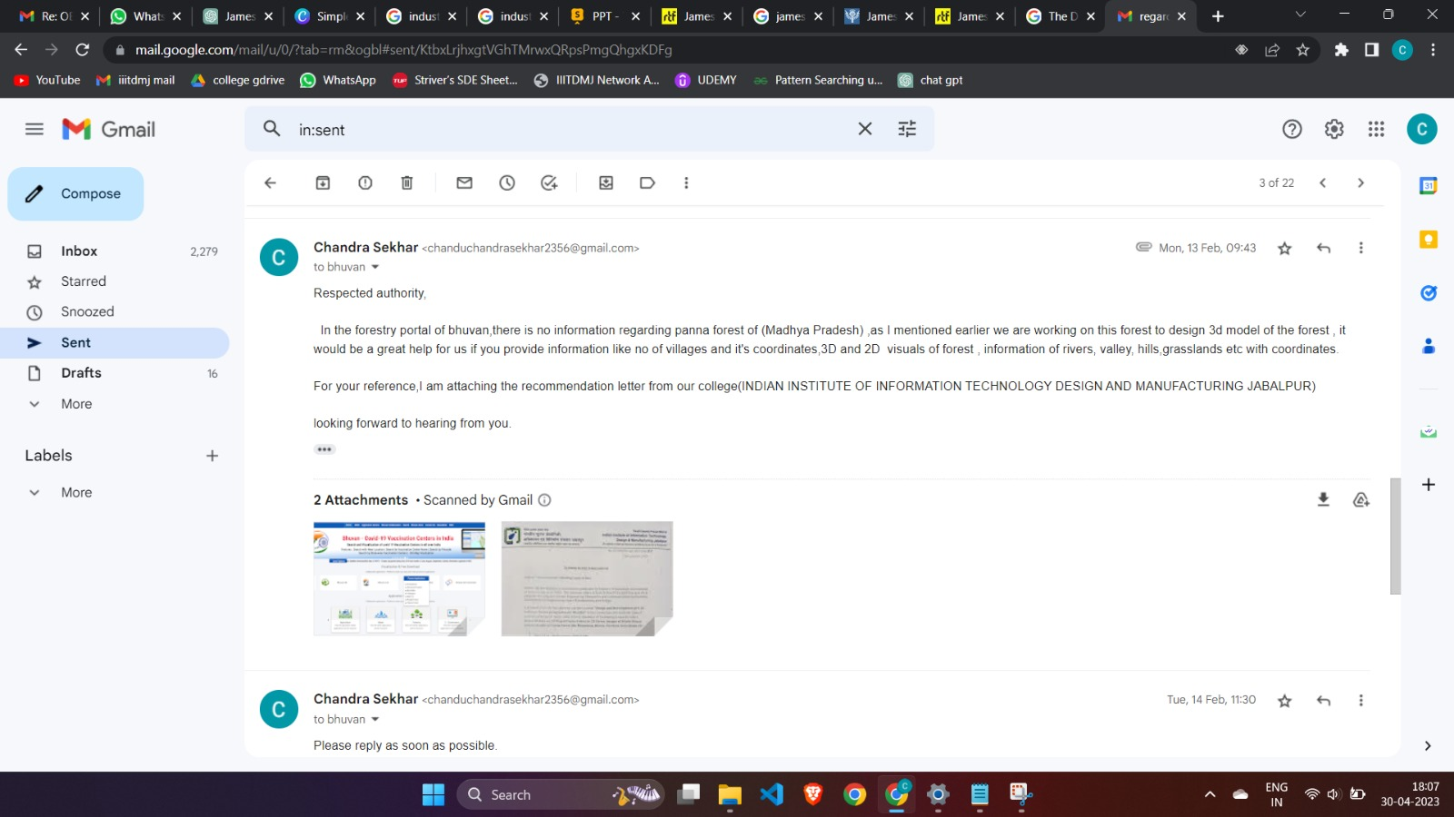

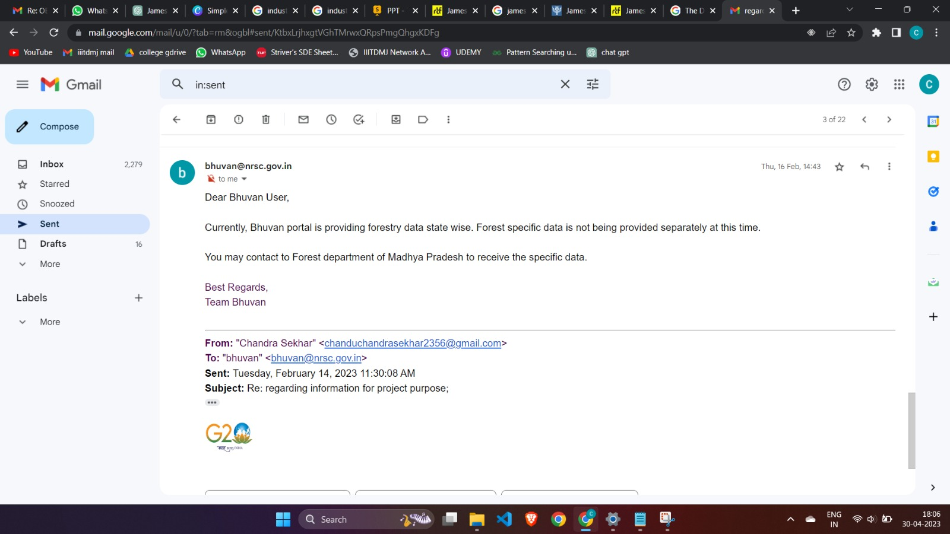

* To analyze the Forest maps we imported the data into the Google earth Pro, using the tools of the google earth pro now we can locate the Forest maps and tiger reserves all across the country

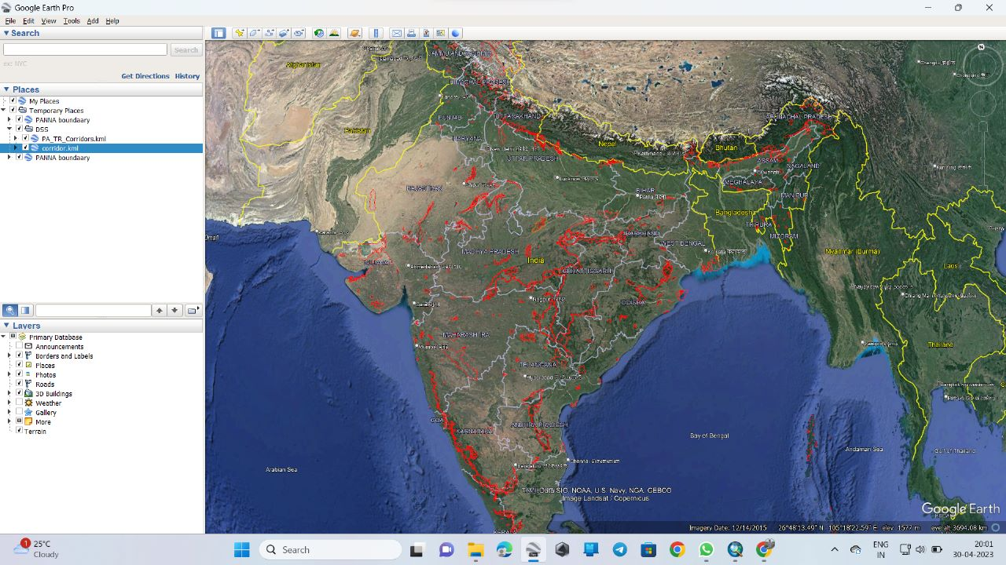

* We’ve taken Google Earth as a reference to understand the boundary of the forest and the coordinates of regions of the forest. We have imported the boundary of the forest and highlighted it the Google Earth for a better understanding of the regions of the forest.

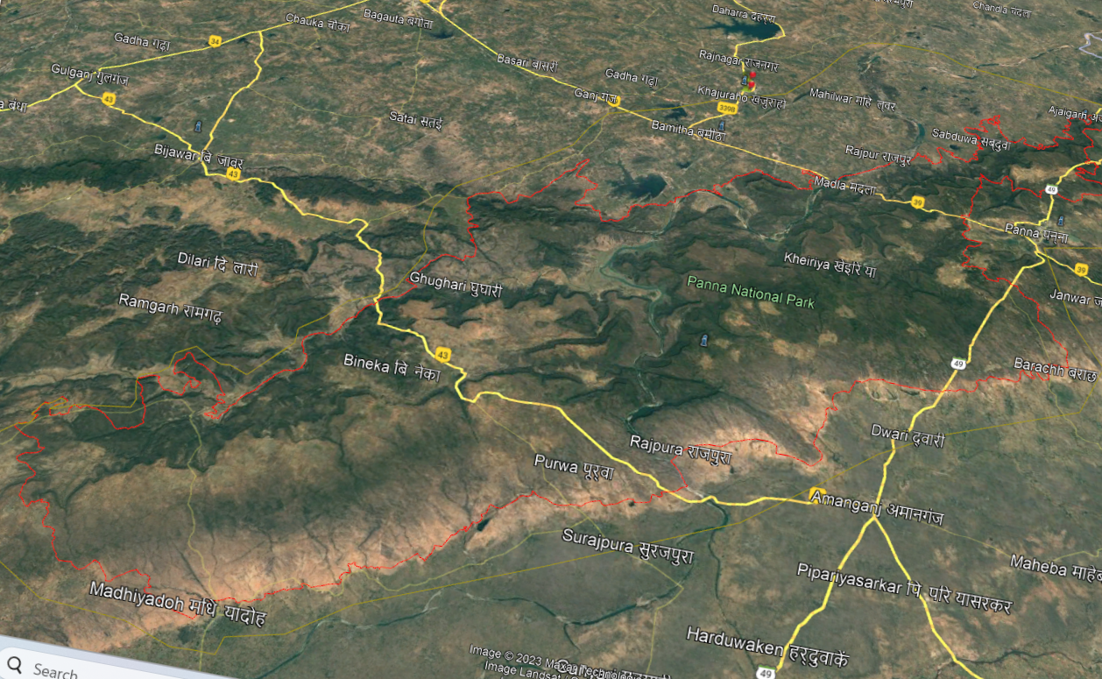

* We have made a 2-D model of the forest initially by purchasing a contour map from Survey of India which includes coordinates and boundaries of the forest. The model is made in a way that we can extract water bodies, state highways, national highways, buffer areas, core areas, and gates of the forest separately. We can even have coordinates in linear plane in meters instead of spherical coordinates (Latitudes) which gives people an easy understanding of distances.

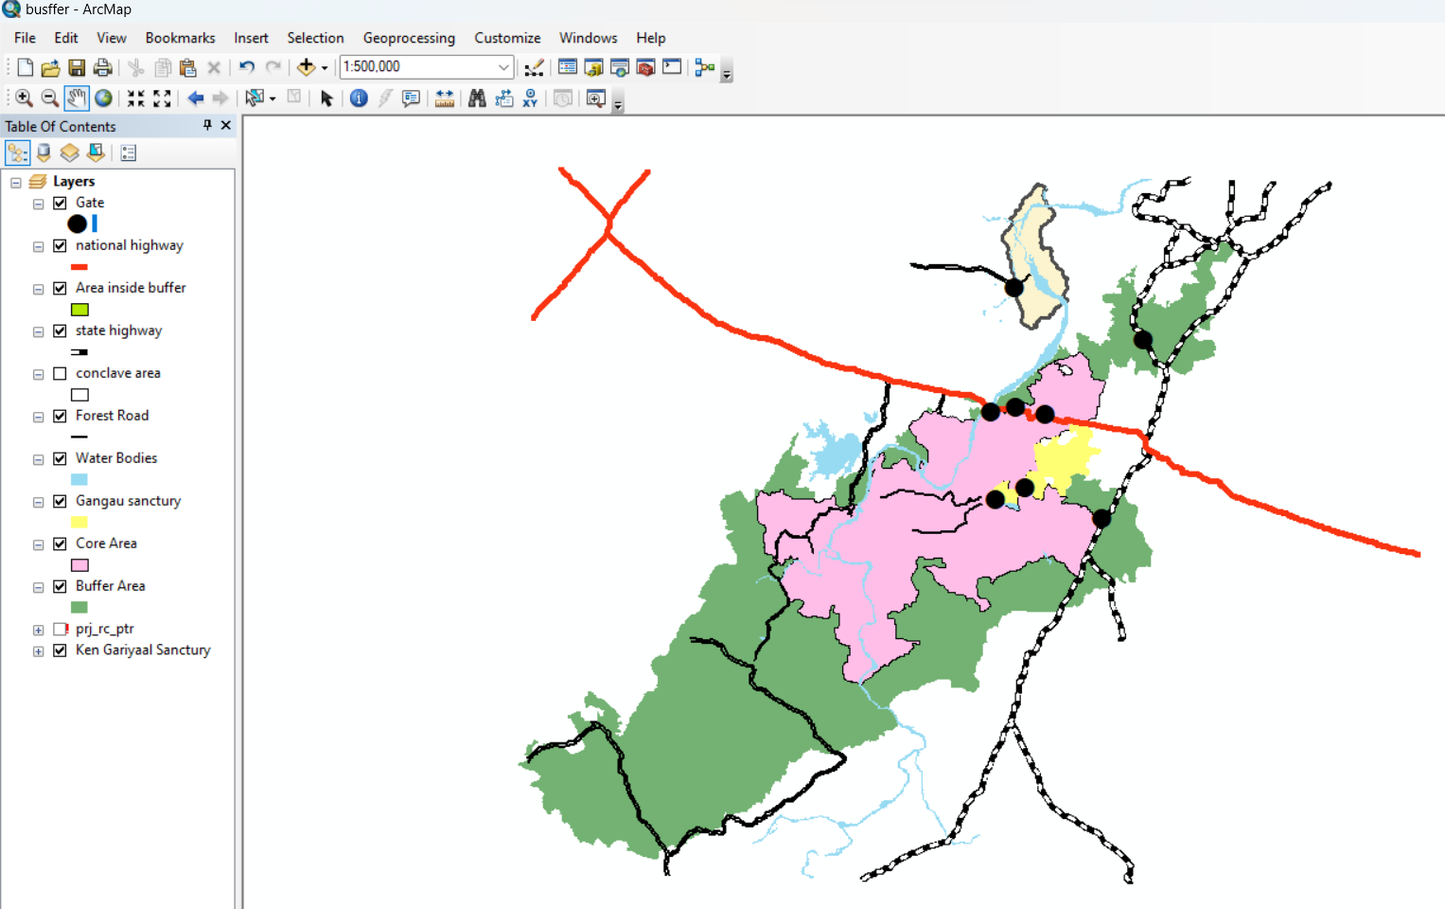

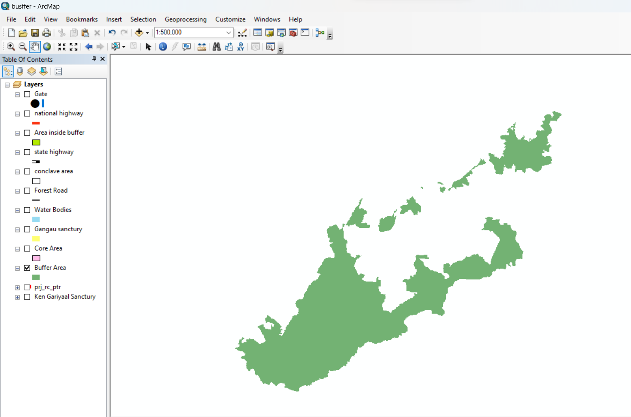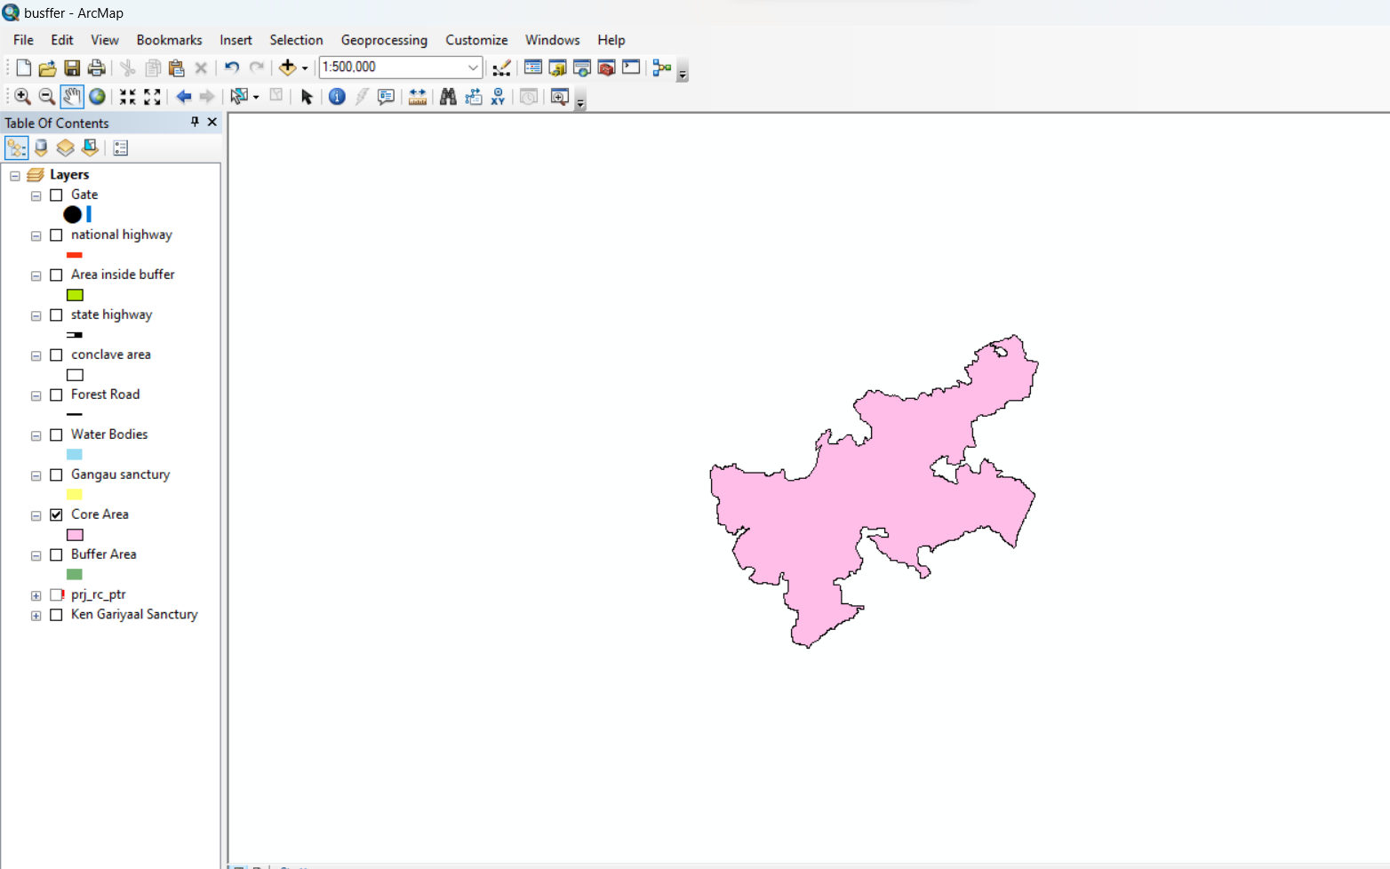

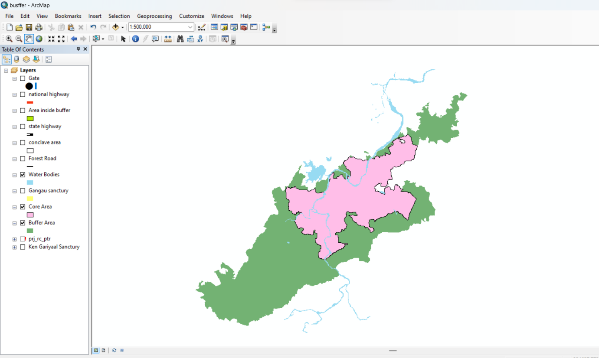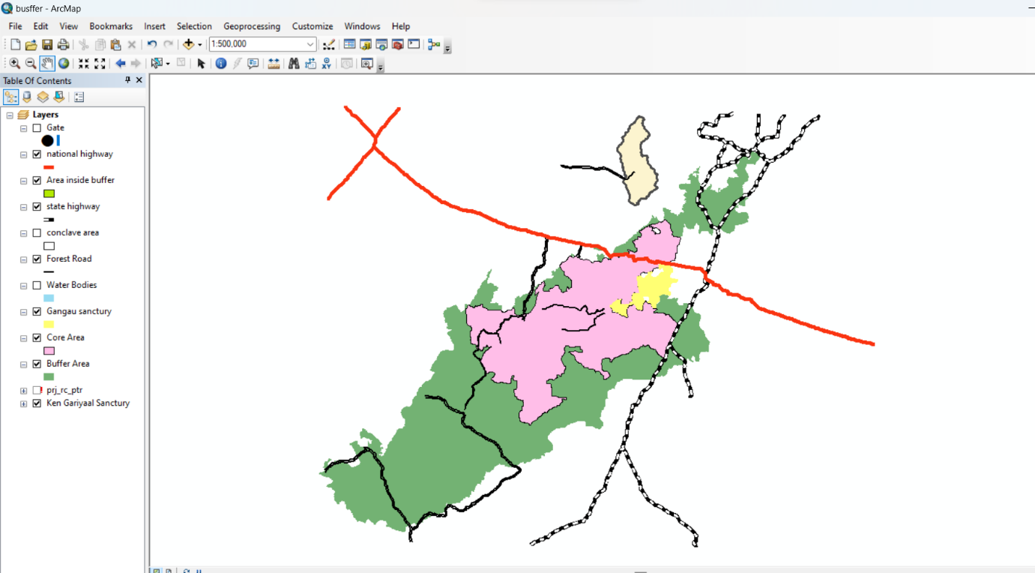

* Using the data, we have in the 2-D map of ArcGIS and the 3-D map of Google Earth, we have created a 3-D model using Blender software. We have included all roads, water bodies, and terrains in the model. We could only make a region of the entire forest due to budget issues as open-source software has limitations on size. Open source also has limitations in importing coordinates onto the 3-D model. So, we could just make a plain model of the forest without including coordinates and altitudes as they are not provided in the free version of the software.

